**Types**

* **int | Integers (no decimal number):** 11
* **float | Real numbers:** 21.213
* **str | Words:** “Hello Python 101”

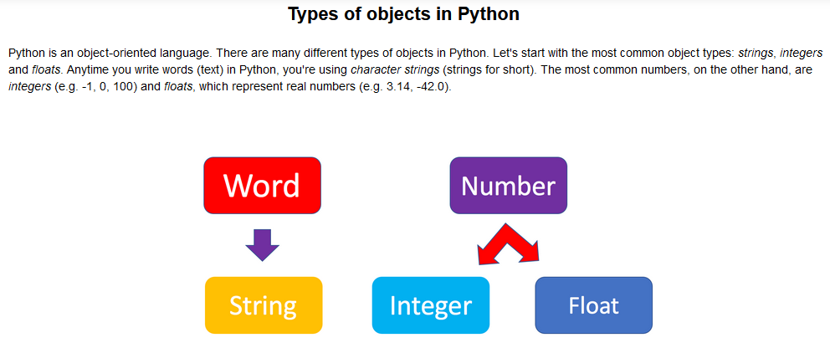

**# Try your first Python output**

print('Hello, Python!')

**# Check the Python Version**

import sys

print(sys.version)

You can get Python to tell you the type of an expression by using the built-in type() function. You'll notice that Python refers to integers as int, floats as float, and character strings as str.

Type(12)

Type(2.14)

Type(‘Hello, world’)